**Image processing & Machine Vision**

**Assignment – 01**

**Name: JAS Sanjana**

**Reg No: D/ENG/22/0001/ET**

**Git Hub Link:** [**https://github.com/SandaliSanjana/Image-Processing-Assingment**](https://github.com/SandaliSanjana/Image-Processing-Assingment)

**Question 01**

Intensity transformation adjusts image brightness, contrast, and other parameters. Intensity transformation is a fundamental method in image processing that modifies pixel values. I've provided the code and findings.

**Question 02**

import cv2 as cv import numpy as np import matplotlib.pyplot as plt

img_orig = cv.imread('D:/Images/highlights_and_shadows.jpg')

img_lab = cv.cvtColor(img_orig, cv.COLOR_BGR2LAB)

L, a, b = cv.split(img_lab)

#apply gamma correction gamma = 1.5

table = np.array([(i/255.0)**(gamma)*255.0 for i in np.arange(0, 256)]).astype('uint8')

L_gamma = cv.LUT(L, table)

#gamma and lab merging img_lab_gamma = cv.merge([L_gamma, a, b])

img_gamma = cv.cvtColor(img_lab_gamma, cv.COLOR_LAB2BGR)

fig, axarr = plt.subplots(3, 2)

axarr[0, 0].imshow(cv.cvtColor(img_orig, cv.COLOR_BGR2RGB))

axarr[0, 0].set_title('Original Image')

axarr[0, 1].imshow(cv.cvtColor(img_gamma, cv.COLOR_BGR2RGB))

axarr[0, 1].set_title('Gamma Corrected Image')

color = ('b', 'g', 'r')

for i, c in enumerate(color):

    hist_orig = cv.calcHist([img_lab], [i], None, [256], [0, 256])

    axarr[1, 0].plot(hist_orig, color=c )

    hist_gamma = cv.calcHist([img_lab_gamma], [i], None, [256], [0, 256])

    axarr[1, 1].plot(hist_gamma, color=c)

axarr[2, 0].plot(table)

axarr[2, 0].set_xlim(0, 255)

axarr[2, 0].set_ylim(0, 255)

axarr[2, 0].set_aspect('equal')

axarr[2, 1].axis('off')

plt.tight_layout()

plt.show()

Histograms are visual representations of the distribution of pixel intensities in a picture. Original histogram color spaces correspond to pixel intensities in the L channel. Quantify the frequency of each intensity level in the image. Gamma correction modifies the relationship between input and output pixel intensities, which affects overall brightness and contrast.

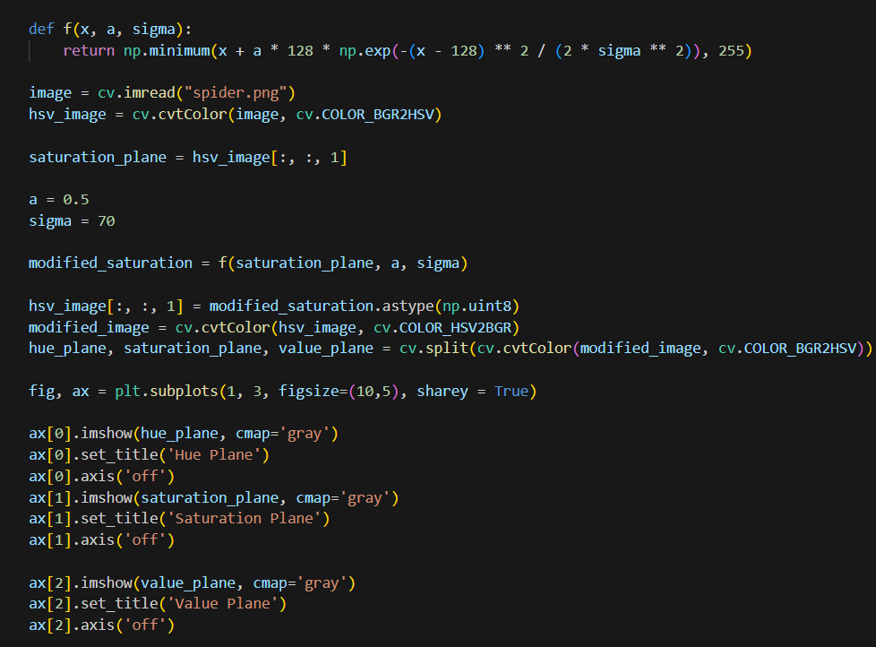**Question 03**

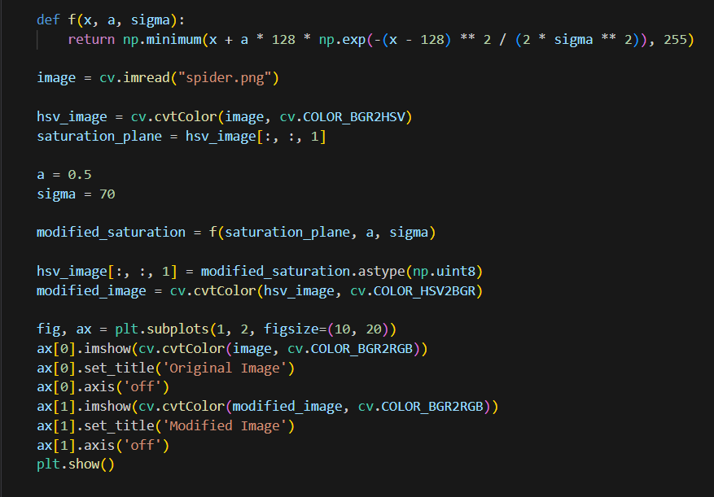

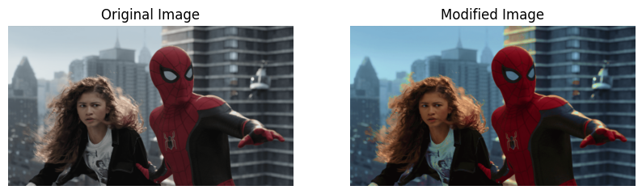

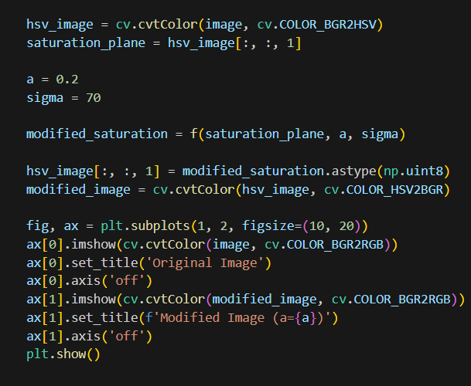

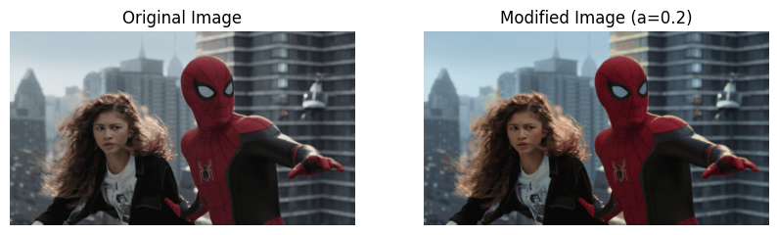

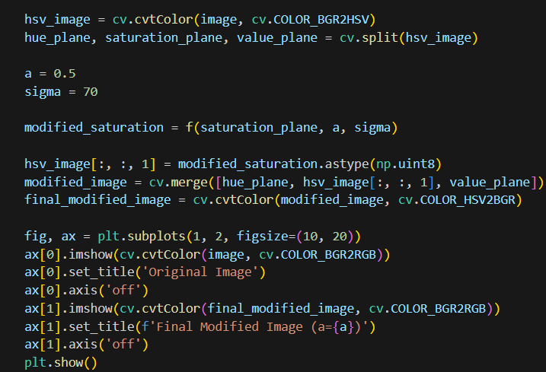

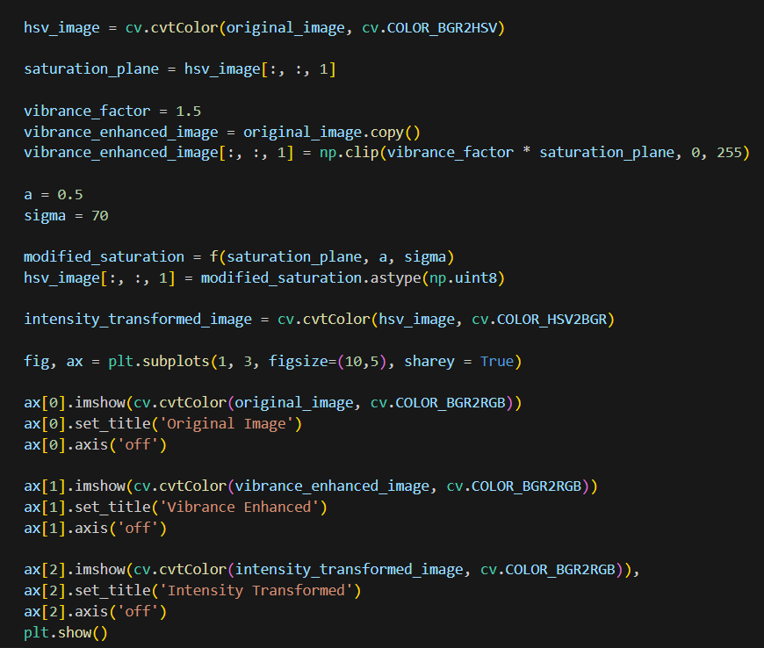

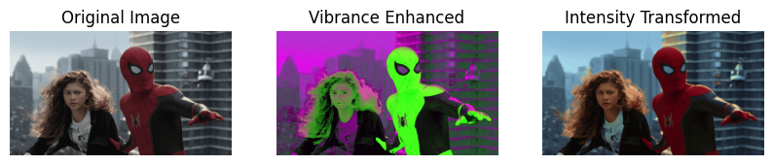

This topic focuses on image improvement, which involves applying intensity transformations to saturation, HUE, and HSV planes to increase vibrance. We focus on improving and bringing out more vibrant colors throughout these three planes. The intensity transformation includes adjusting a parameter 'a' to obtain a desirable vibrance boost.

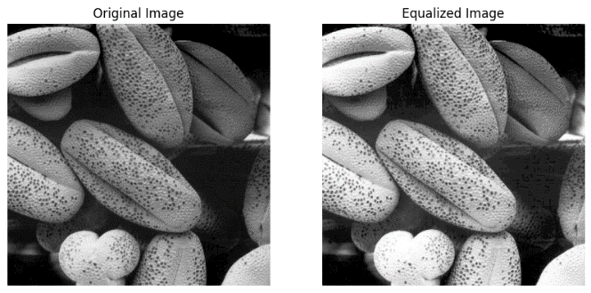**Question 04**

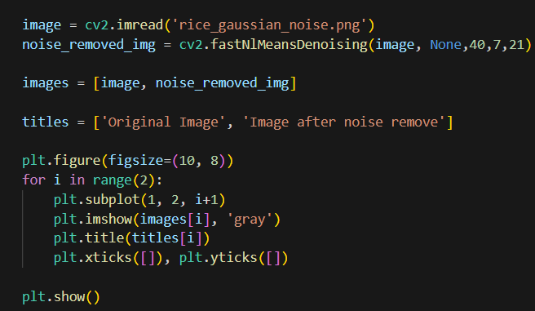**Question 05**

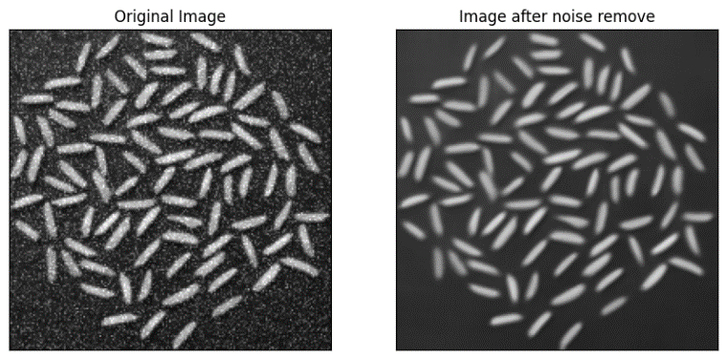

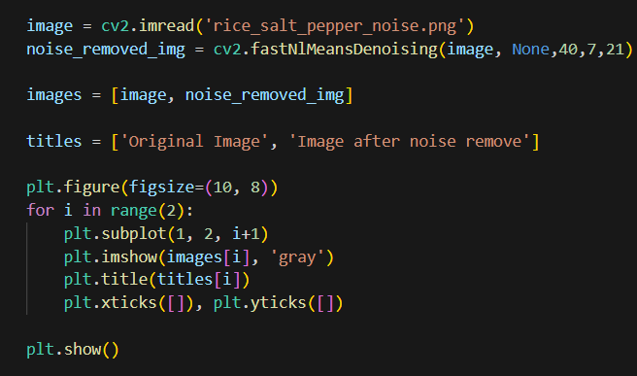

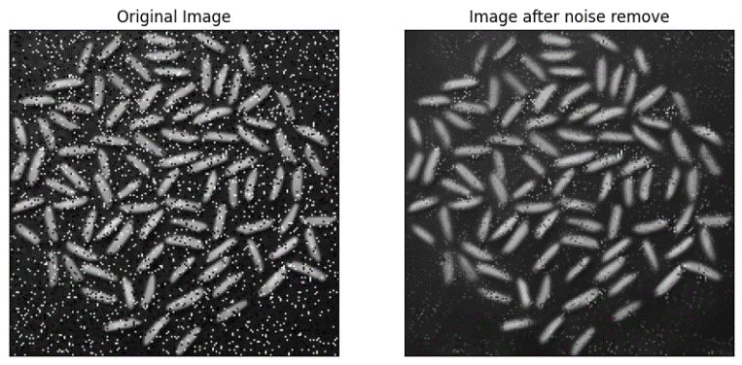

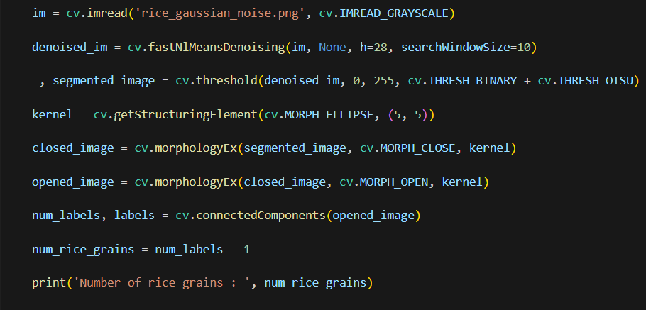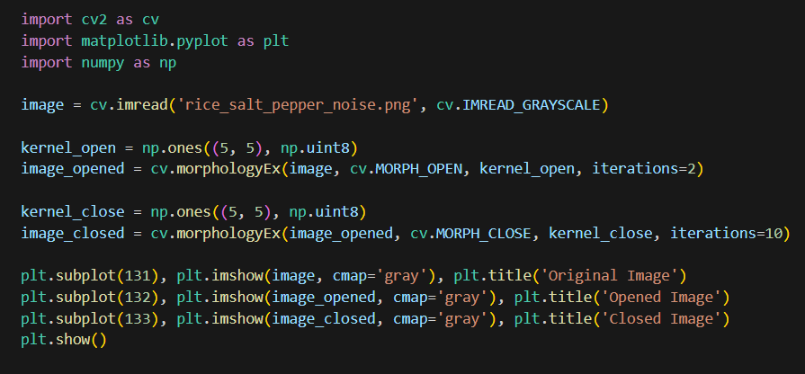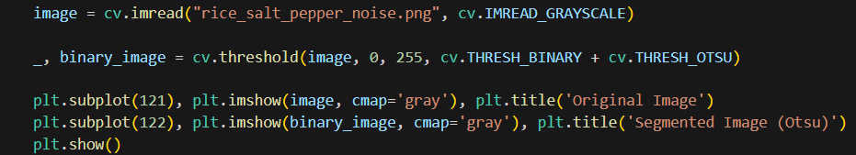

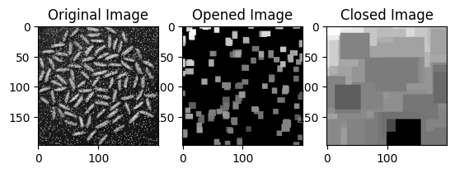

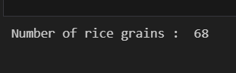 

Otsu's approach was used to segment the images, separating rice grains from the backdrop.   
Morphological operations refine segmentation by removing minor artifacts and filling in gaps.

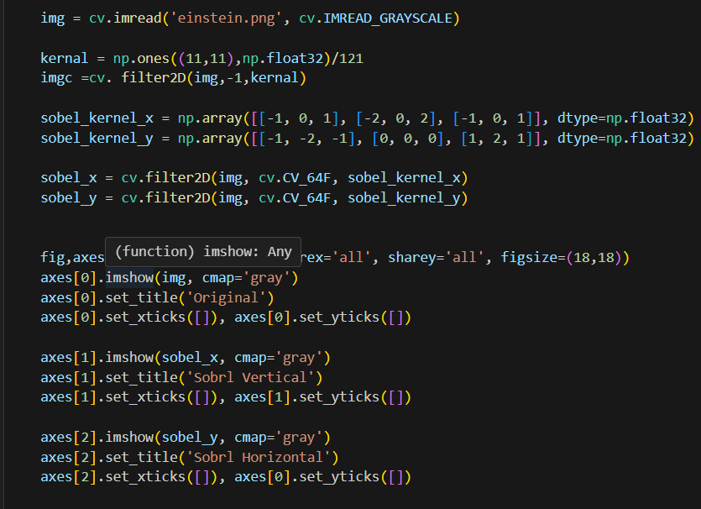**Question 06**

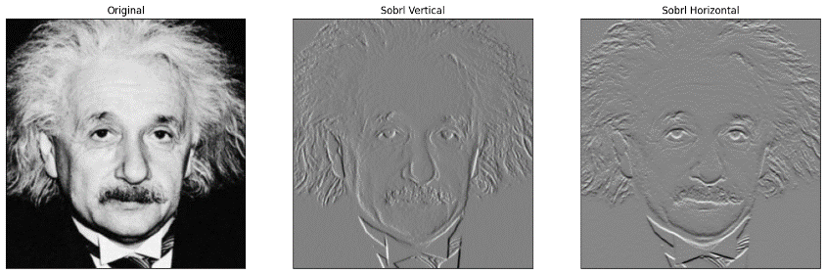

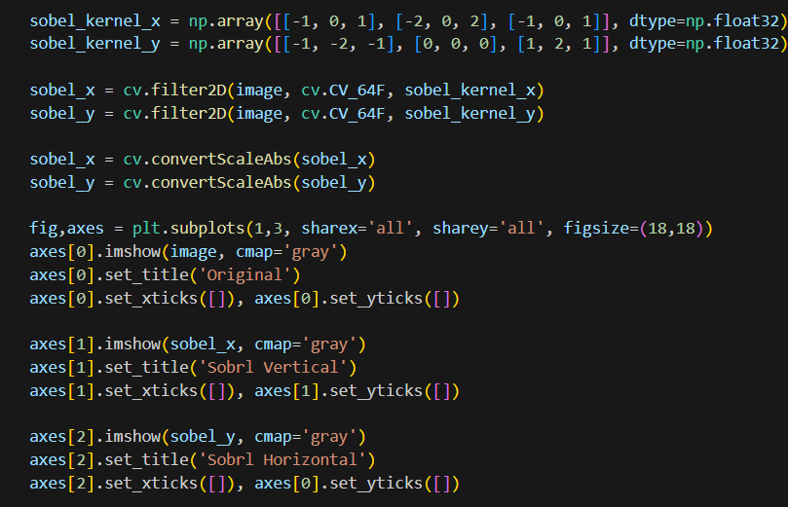

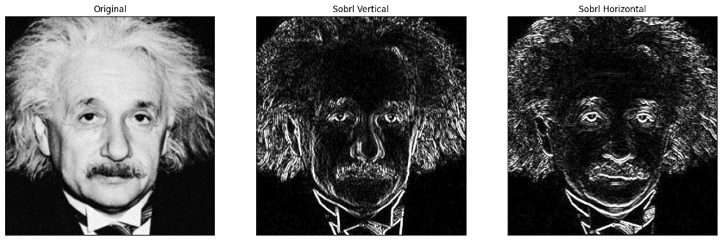

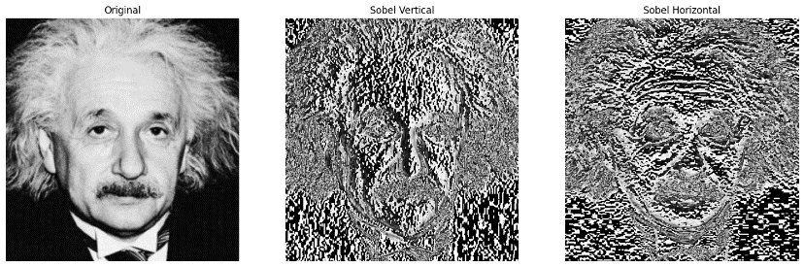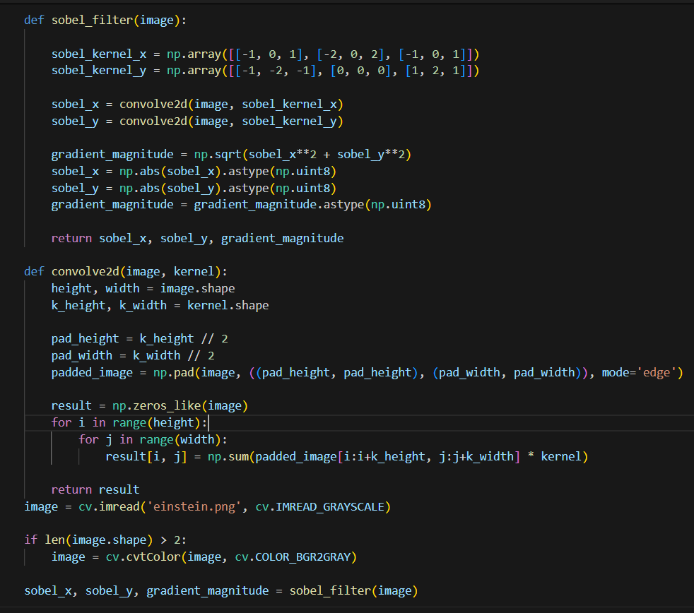

Sobel filtering is a significant approach in image processing that uses intensity fluctuations to find edges. Figure 6 illustrates three approaches. The filter2D function allows for effective and fast Sobel filtering. Second, a custom Sobel filter implementation allows for interactive exploration of the underlying computations.

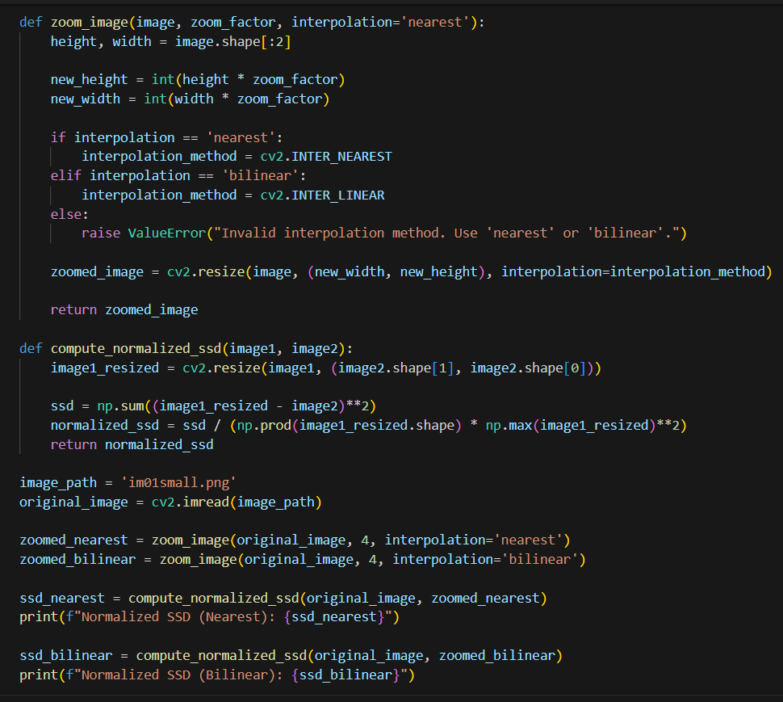**Question 07**

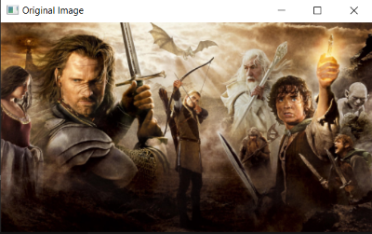

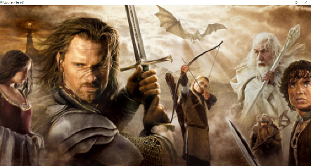

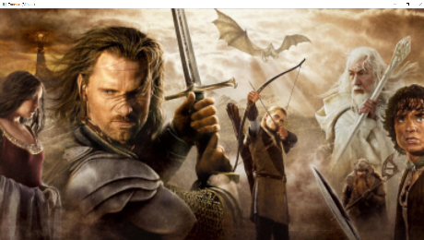

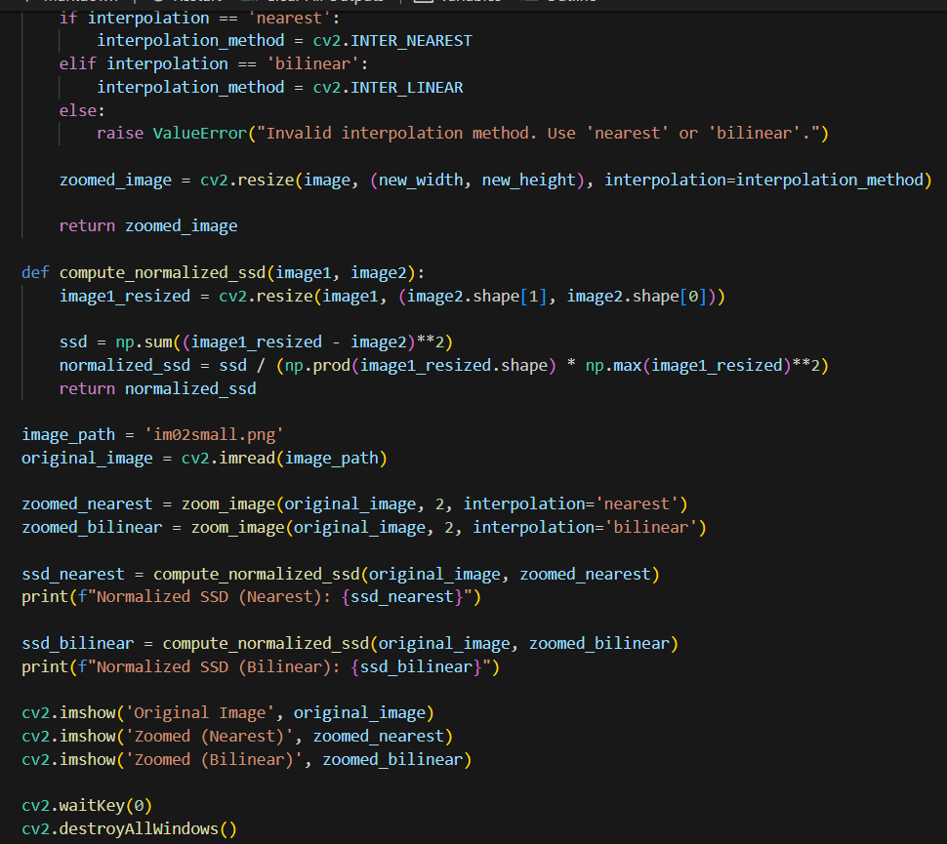

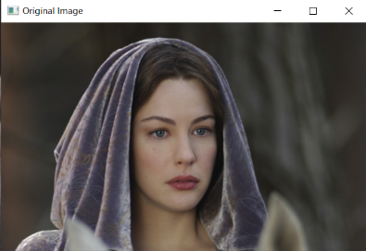

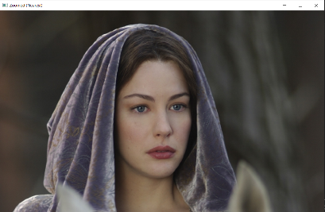

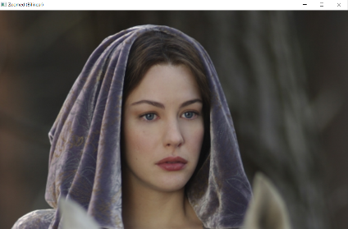

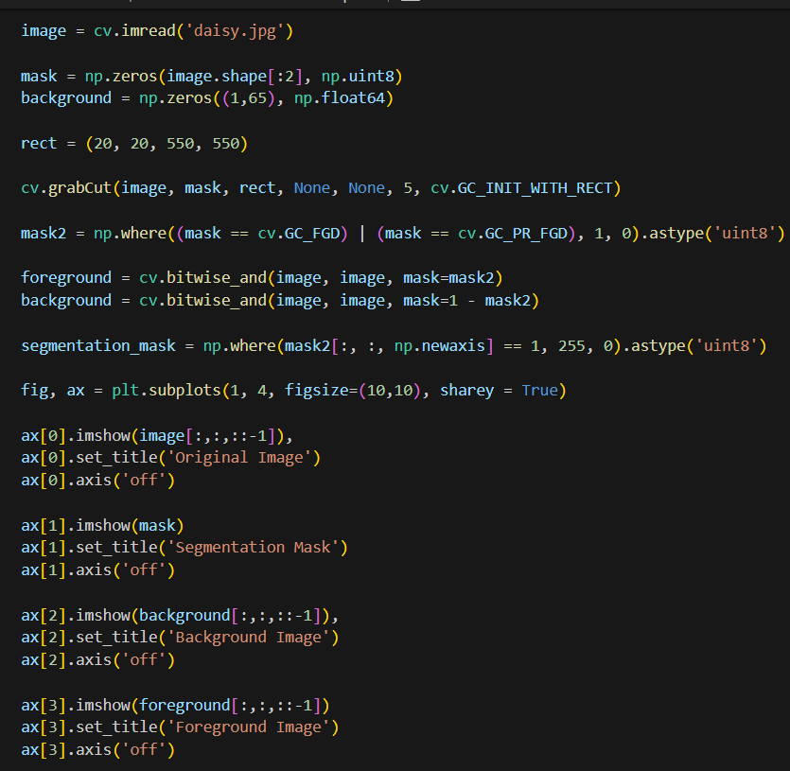**Question 08**

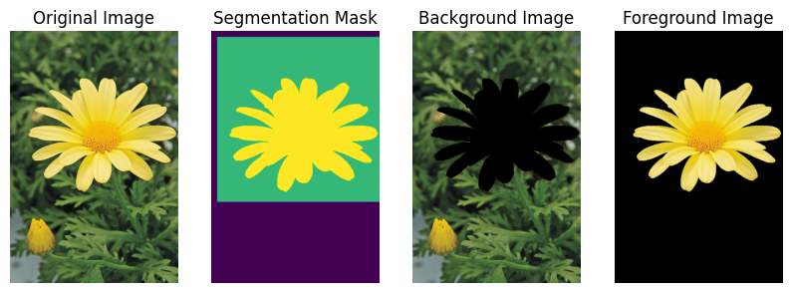

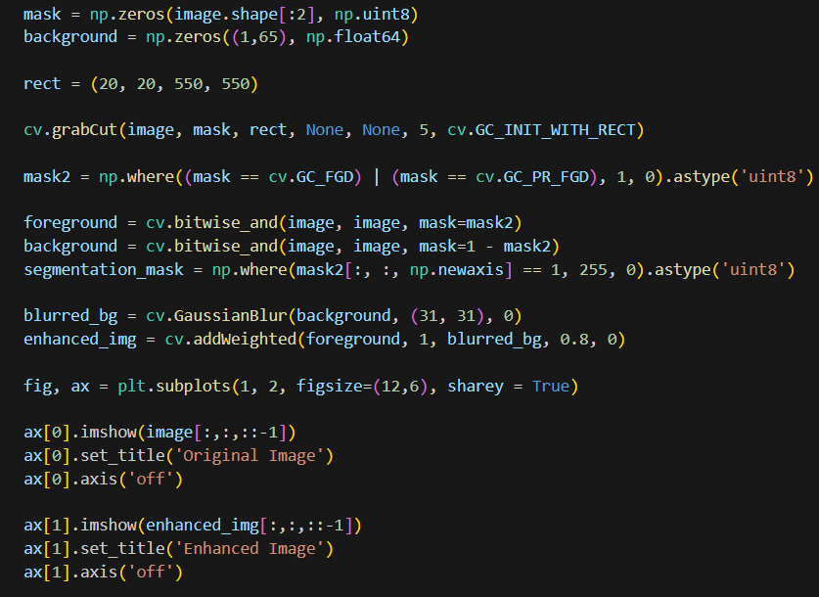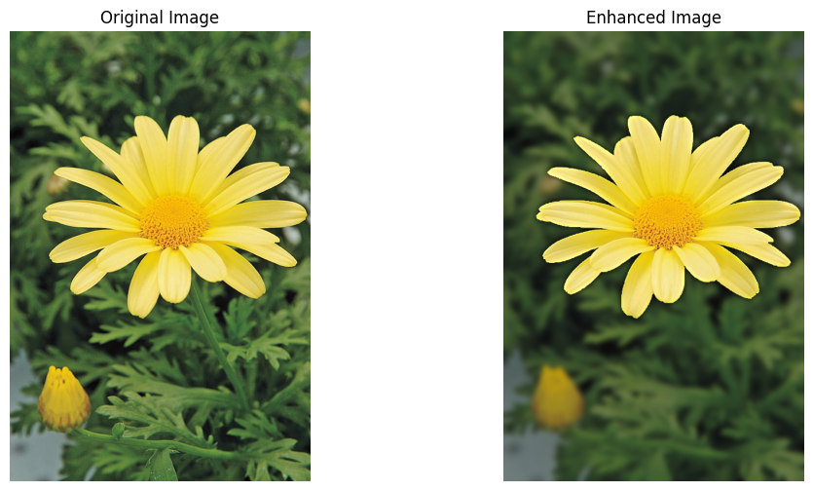

c. The darker backdrop in the improved image is primarily due to a Gaussian blur applied to the background, extending beyond the flower's boundary. Grab Cut divides the image into foreground (flower) and background. The background is then smoothed using a Gaussian blur with a kernel size of (15, 15). The smoothing effect averages pixel values, making the backdrop appear darker. To improve the image, combine the sharp foreground and blurring backdrop. Variables like kernel size can adjust blurring and darkness in the backdrop.